# BANK DATABASE

**QUESTION**

(WEEK3)

Branch (branch-name: String, branch-city: String, assets: real)

BankAccount(accno: int, branch-name: String, balance: real)

BankCustomer (customer-name: String, customer-street: String,

customer-city: String)

Depositer(customer-name: String, accno: int)

LOAN (loan-number: int, branch-name: String, amount: real)

1.Create the above tables by properly specifying the primary keys and the foreign

keys.

2.Enter at least five tuples for each relation.

3.Display the branch name and assets from all branches in lakhs of rupees and rename

the assets column to 'assets in lakhs'.

4.Find all the customers who have at least two accounts at the same branch (ex.

SBI_ResidencyRoad).

5.CREATE A VIEW WHICH GIVES EACH BRANCH THE SUM OF THE

AMOUNT OF ALL THE LOANS AT THE BRANCH.

**Schema diagram:**

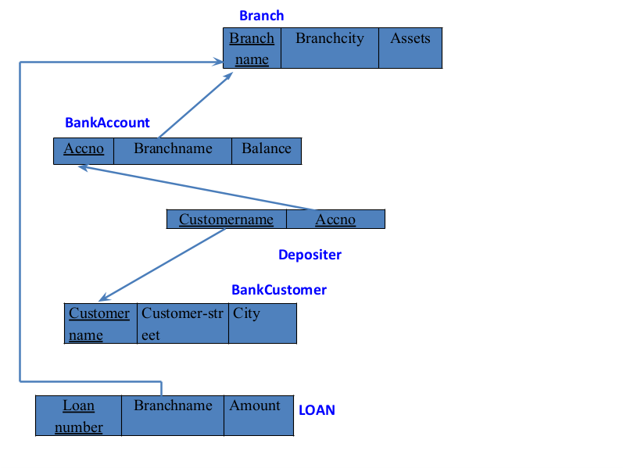

**Create database:**

create database bank1;

use bank1;

**create table:**

create table branch (

branch_name varchar(25),

branch_city varchar(15),

assets int,

primary key (branch_name)

);

create table bank_account (

accno int,

branch_name varchar(25),

balance int,

primary key (accno),

foreign key (branch_name) references branch(branch_name)

);

create table bank_customer (

customer_name varchar(10),

customer_street varchar(25),

customer_city varchar(15),

primary key (customer_name)

);

create table depositer (

customer_name varchar(10),

accno int,

primary key(customer_name, accno),

foreign key (customer_name) references bank_customer(customer_name),

foreign key(accno) references bank_account(accno)

);

create table loan (

loan_number int,

branch_name varchar(25),

amount int,

primary key (loan_number),

foreign key (branch_name) references branch(branch_name)

);

**Strucure of the table:**

DESC bank_account;

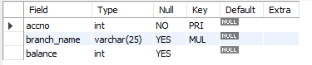

DESC branch;

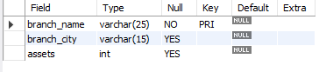

DESC bank_customer;

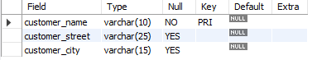

DESC depositer;



DESC loan;

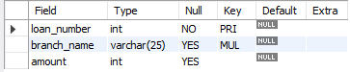

**Inserting values to the table:**

insert into branch values('SBI_Chamrajpet', 'Bangalore', 50000);

insert into branch values('SBI_ResidencyRoad', 'Bangalore', 10000);

insert into branch values('SBI_ShivajiRoad', 'Bombay', 20000);

insert into branch values('SBI_ParliamentRoad', 'Delhi', 10000);

insert into branch values('SBI_Jantarmantar', 'Delhi', 20000);

select * from branch;

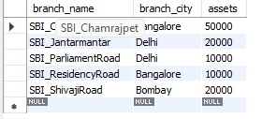

insert into bank_account values(1, 'SBI_Chamrajpet', 2000);

insert into bank_account values(2, 'SBI_ResidencyRoad', 5000);

insert into bank_account values(3, 'SBI_ShivajiRoad', 6000);

insert into bank_account values(4, 'SBI_ParliamentRoad', 9000);

insert into bank_account values(5, 'SBI_Jantarmantar', 8000);

insert into bank_account values(6, 'SBI_ShivajiRoad', 4000);

insert into bank_account values(8, 'SBI_ResidencyRoad', 4000);

insert into bank_account values(9, 'SBI_ParliamentRoad', 3000);

insert into bank_account values(10, 'SBI_ResidencyRoad', 5000);

insert into bank_account values(11, 'SBI_Jantarmantar', 2000);

select * from bank_account;

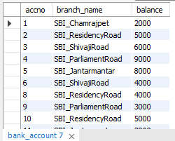

insert into bank_customer values ('Avinash', 'Bull_Temple_Road', 'Bangalore');

insert into bank_customer values ('Dinesh', 'Bannergatta_Road', 'Bangalore');

insert into bank_customer values ('Mohan', 'National_College_Road', 'Bangalore');

insert into bank_customer values ('Nikhil', 'Akbar_Road', 'Delhi');

insert into bank_customer values ('Ravi', 'Prithviraj_Road', 'Delhi');

select * from bank_customer;

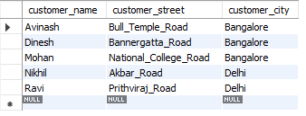

insert into depositer values('Avinash', 1);

insert into depositer values('Dinesh', 2);

insert into depositer values('Nikhil', 4);

insert into depositer values('Ravi', 5);

insert into depositer values('Avinash', 8);

insert into depositer values('Nikhil', 9);

insert into depositer values('Dinesh', 10);

insert into depositer values('Nikhil', 11);

select * from depositer;

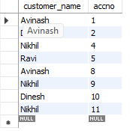

insert into loan values(1, 'SBI_Chamrajpet', 1000);

insert into loan values(2, 'SBI_ResidencyRoad', 2000);

insert into loan values(3, 'SBI_ShivajiRoad', 3000);

insert into loan values(4, 'SBI_ParliamentRoad', 4000);

insert into loan values(5, 'SBI_Jantarmantar', 5000);

select * from loan;

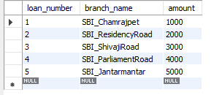

**Query1:**

Create the above tables by properly specifying the primary keys and the foreign

keys.